11 CLASSY ELEGANT VALENTINE’S DINNER OUTFITS: MINIMALIST EDITION

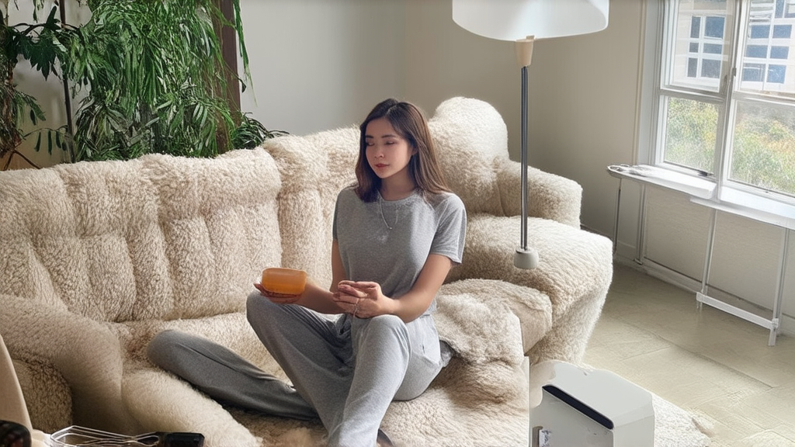

Valentine’s Day dinner is the ultimate excuse to dress up but nobody wants to look like they tried too hard. Finding that perfect balance between effortless and high-end is the key to a memorable night. You want an outfit that speaks for itself without screaming for attention. Minimalist fashion allows your natural beauty and personality to take center stage while you enjoy a romantic meal.  
  
Minimalism is the secret weapon for a sophisticated evening look. It focuses on clean lines, neutral tones, and premium fabrics that feel as good as they look. Forget the over-the-top sequins and neon pinks because this year is all about quiet luxury. Investing in a few key pieces ensures you look polished and timeless regardless of where the night takes you.  
  
These 11 classy elegant Valentine’s dinner outfits: minimalist edition will guide you through the best style choices for your romantic plans. Each look prioritizes comfort and timelessness so you can focus on the conversation instead of adjusting your hemline. These selections prove that simplicity is the highest form of sophistication for any modern woman.  
  
Scroll down to discover your new favorite date night aesthetic.

# Silk Slip Dress in Champagne

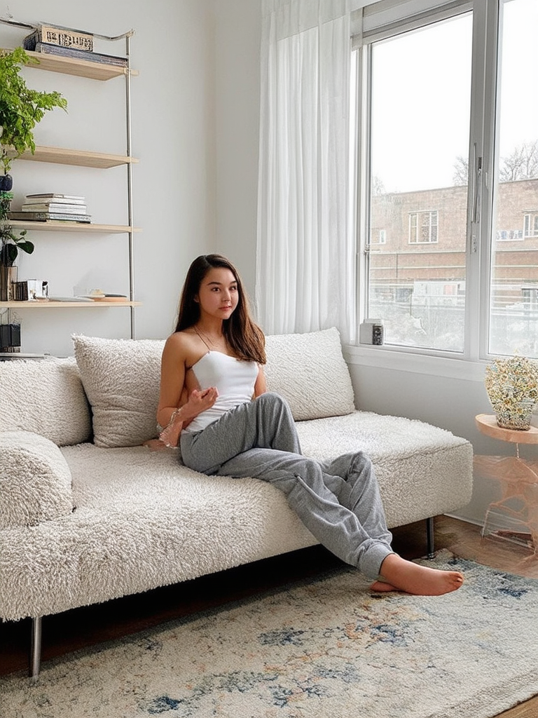

A bias-cut silk slip dress remains the gold standard for understated glamour. Choose a muted champagne or cream tone to keep the vibe soft and romantic. Layer it with a structured oversized blazer if the restaurant is chilly. Finish the look with thin gold chains and a pair of strappy heeled sandals.

# Black Column Maxi Dress

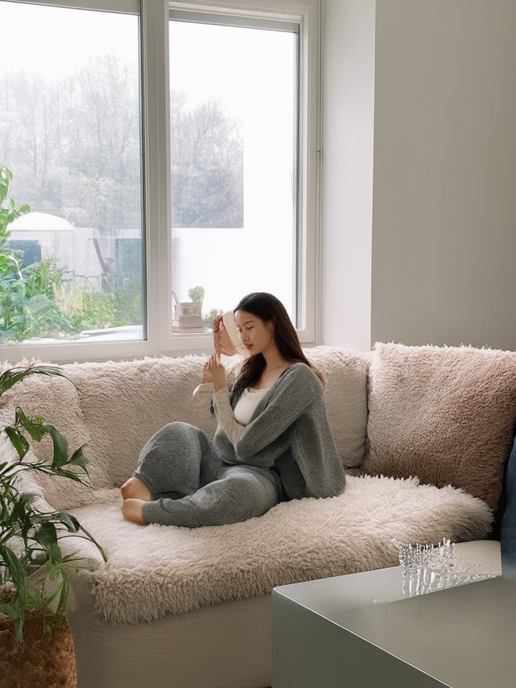

Nothing beats the sleek silhouette of a black column maxi dress for a formal dinner. The straight lines create an elongated profile that looks expensive and intentional. Opt for a high neckline to maintain a modest yet powerful presence. This piece works best with slicked-back hair and architectural silver earrings.

# Monochrome Cream Trouser Set

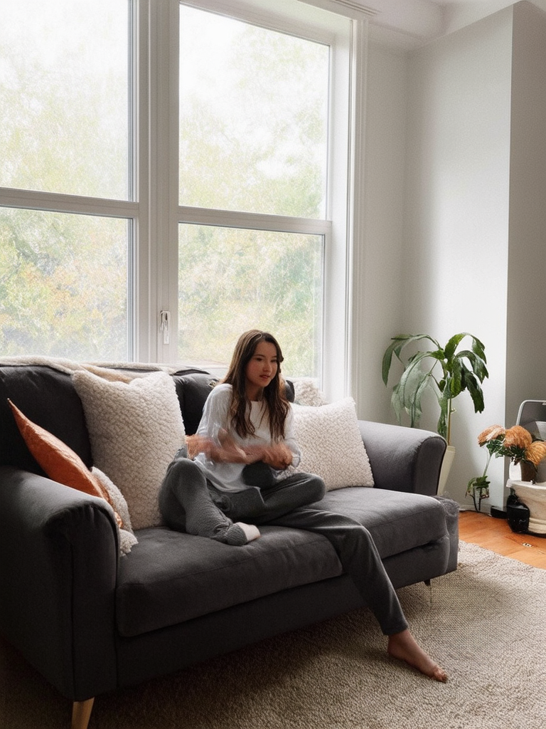

Wearing head-to-toe cream signals luxury and confidence. Pair wide-leg wool trousers with a matching silk camisole for a texture-rich ensemble. This monochromatic approach simplifies your morning routine while maximizing your style impact. Add a pointed-toe bootie to keep the look sharp and modern.

# Satin Midi Skirt and Cashmere Sweater

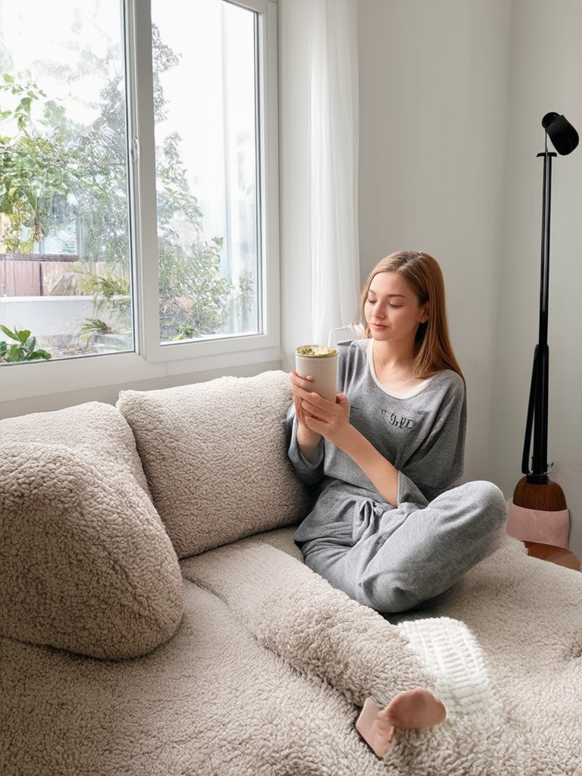

Mixing textures is the easiest way to make a minimalist outfit feel curated. A heavy cashmere sweater tucked into a fluid satin midi skirt provides the perfect contrast. Choose shades like charcoal or chocolate brown for a moody and sophisticated palette. This combination is ideal for a cozy candlelit dinner at a boutique bistro.

# Off-the-Shoulder Knit Bodycon

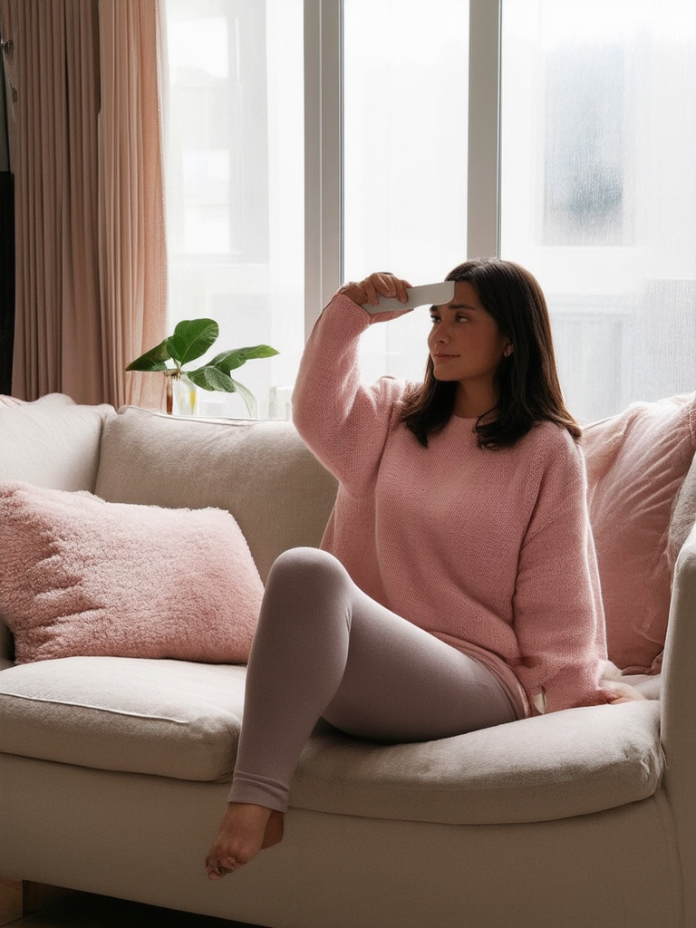

An off-the-shoulder neckline adds a touch of subtle allure without being revealing. Look for a ribbed knit material that hugs the body comfortably and keeps its shape. The texture of the knit prevents the outfit from looking flat or boring. Style it with a simple clutch and a bold red lip for a classic touch.

# Tailored White Blazer Dress

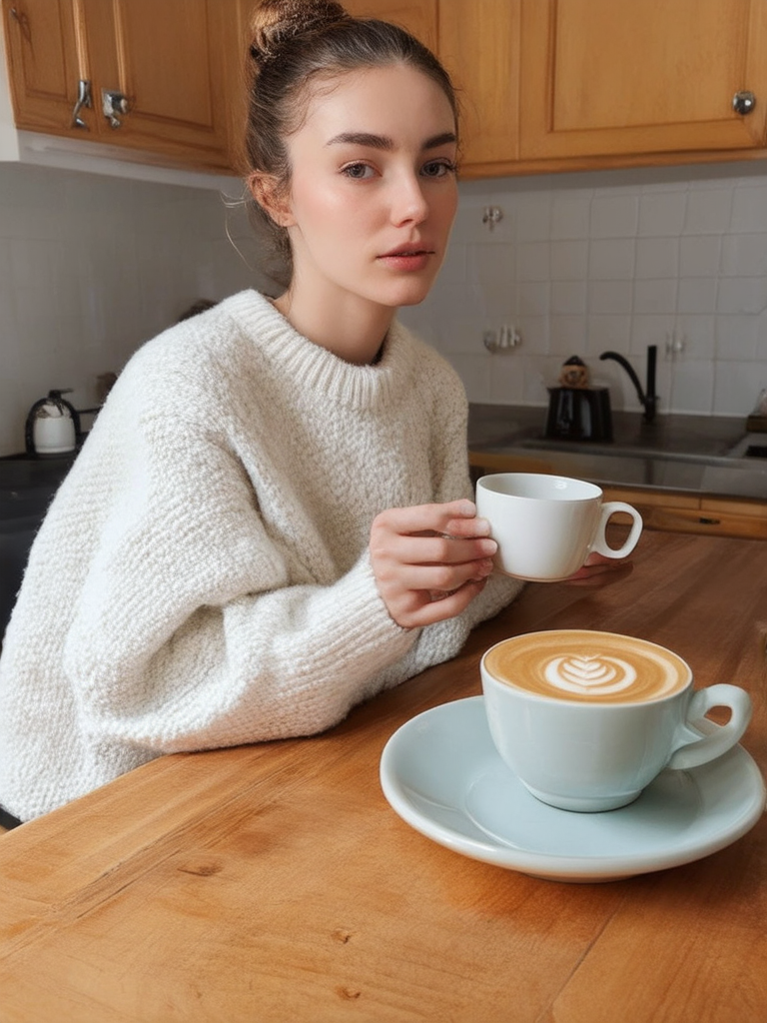

A structured blazer dress is the ultimate power move for a Valentine's date. The sharp shoulders and defined waist create a professional yet feminine silhouette. Keep the accessories minimal to let the tailoring of the garment take center stage. This outfit is perfect for anyone who wants to ditch the traditional dress for something bolder.

# High-Neck Halter Top with Leather Pants

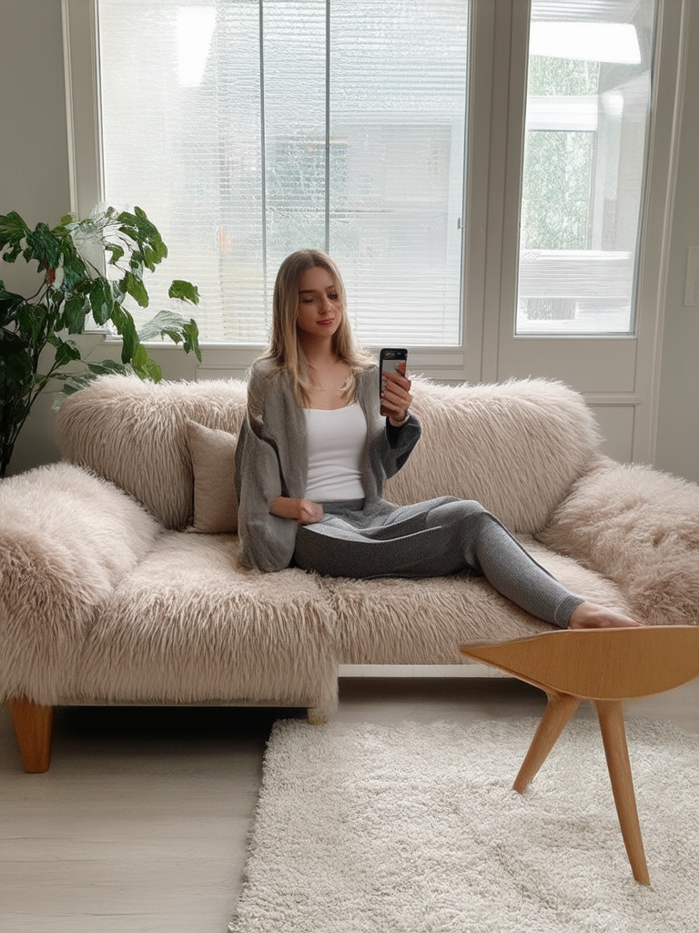

Combine a sophisticated high-neck halter top with straight-leg leather trousers for a cool edge. The leather adds a modern grit to an otherwise classic minimalist look. Stick to a neutral color palette like black on black or tan and cream. Complete the outfit with a pair of minimalist mules for an effortless finish.

# Sheer Long-Sleeve Layer over Slip

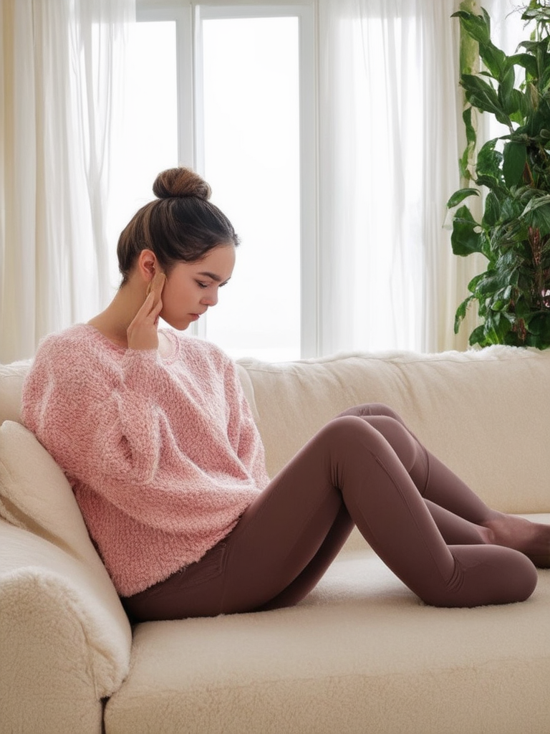

Add a layer of intrigue by wearing a sheer mesh top over a simple slip dress. This creates depth and visual interest while staying within a minimalist framework. It provides just enough coverage for a winter evening while remaining undeniably chic. Keep your jewelry dainty to ensure the layering remains the main focus.

# Backless Mid-Length Dress

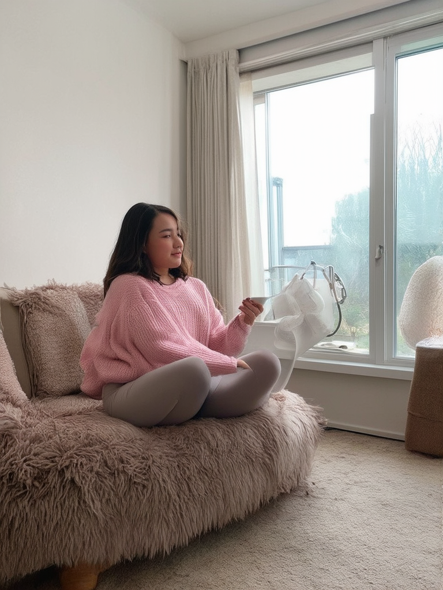

Surprise your date with a dress that looks simple from the front but features a dramatic open back. This detail adds an unexpected element of elegance that feels very high-fashion. Choose a heavy jersey or crepe fabric that drapes beautifully over your curves. A simple updo is necessary to showcase the unique back detail of this piece.

# Square-Neck Mini with Sheer Tights

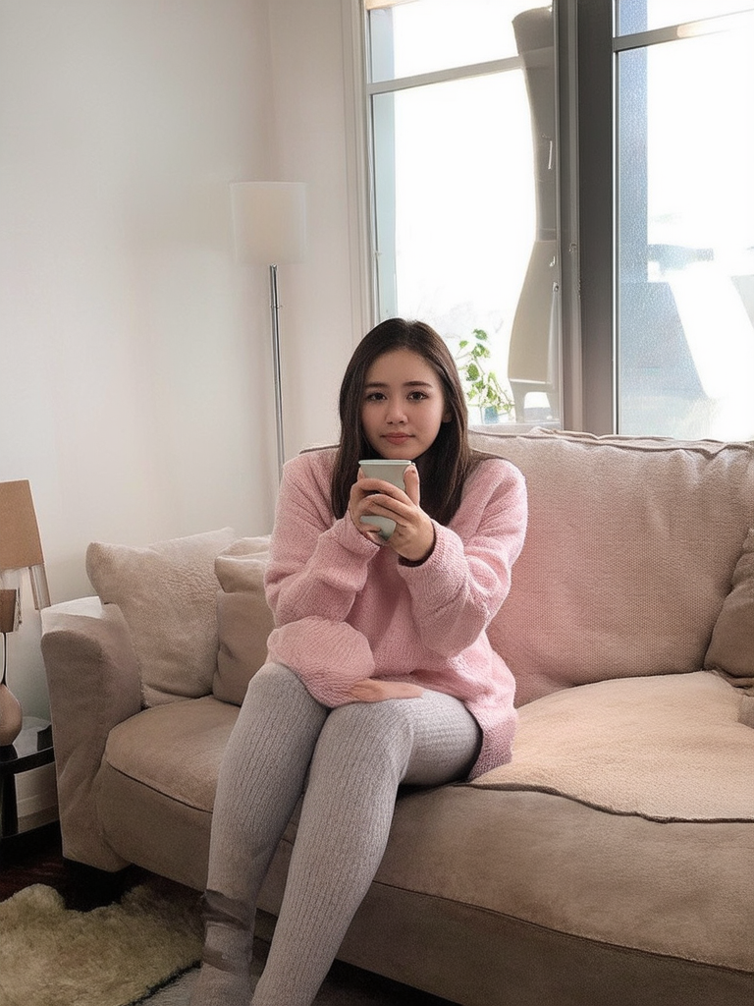

A square-neckline offers a vintage-inspired look that feels incredibly fresh for

# Pair a structured mini dress with high-quality sheer black tights for a polished aesthetic. This look balances youthful energy with sophisticated styling choices. Round out the ensemble with chunky loafers or sleek slingbacks.

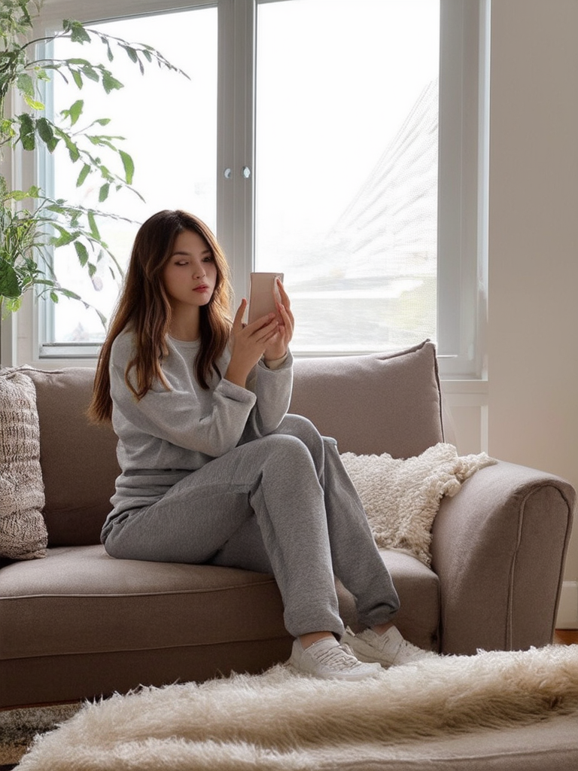

# Silk Button-Down and Micro-Mini Skirt

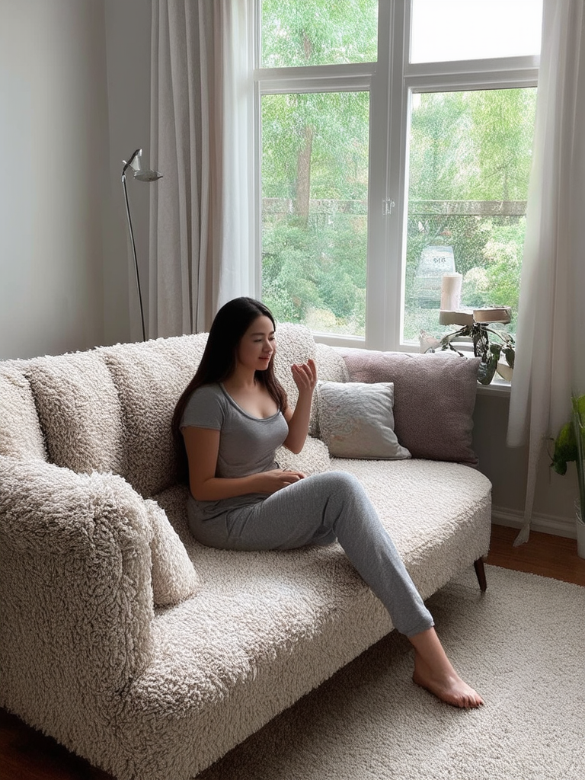

Elevate a standard silk button-down by pairing it with a structured micro-mini skirt. Leaving a few buttons undone creates a relaxed and approachable vibe for your dinner date. Tuck the shirt in to emphasize your waistline and keep the proportions balanced. This outfit proves that basic wardrobe staples can become iconic with the right styling.

# Conclusion

Mastering the art of minimalist dressing means choosing quality over quantity every single time. These outfits prove you do not need bright colors or heavy embellishments to make a lasting impression. Confidence is your best accessory when you wear clothes that reflect your personal style. Keeping things simple allows your genuine connection with your partner to be the focus of the evening.  
  
Valentine's Day is about celebrating connection and your outfit should make you feel like the best version of yourself. Whether you choose a silk dress or tailored trousers you are ready for a beautiful evening. Take these ideas and adapt them to what makes you feel most powerful and comfortable. True elegance is found in the details and the way you carry yourself throughout the night.  
  
Now is the time to head to your closet and start experimenting with these combinations. Pick your favorite look from the list and prepare for a night of effortless elegance. Share your final date night look on social media and tag your best friends for more style inspiration.